
Web Support Officer

Salary: £33,699 up to £38,220 per annum pro rata (Pay award pending)
Grade: 6
Location: Hinckley, Leicestershire (Hybrid working available)
Contract: 37 hours per week, Monday to Friday, Permanent contract

About the role
Do you enjoy making online services work better for people?
We’re looking for a web support officer to join our Communications Team, supporting the council’s website, online forms, CRM system and digital processes.
You’ll work with colleagues across the council, including ICT, to help keep services accurate, accessible and easy to use.
If that sounds like you, we’d like to hear from you.

What you will be doing
- Working proactively with services across the council to design and develop online forms for our customers which comply with both data protection and web accessibility legislation.
- Support the web channel by ensuring content is accessible, current and clear.
- Take responsibility for our Customer Services - Customer Relationship Management (CRM) system for our Customer Services Team.
- Provide support for our intranet

About you
You’ll need some experience of websites, systems or digital services, along with good digital skills, an eye for detail and a practical approach to solving problems. You’ll also be keen to keep learning.

Essential criteria
We are particularly interested in candidates with experience in:
- Website administration or digital service delivery.
- Online form design and development.
- CRM systems or customer relationship management platforms.
- Business process mapping and service improvement.
- Working accurately with excellent attention to detail.
- Managing workloads and meeting deadlines.
- Following standards, procedures, and publishing guidelines.
- Troubleshooting and problem solving.
- Excellent written English and communication skills.
- Microsoft Word proficiency.
- Knowledge of web accessibility standards and inclusive digital design.

Find out more
For an informal discussion about this exciting opportunity please call Jacqueline Puffett, Communications Manager on 01455 238141.
Apply with your CV and supporting statement via our online application form at https://jobsandcareers.hinckley-bosworth.gov.uk or for an application pack call 01455 255836 quoting position reference: R212

Closing date: 17 July 2026
Interview date: To be confirmed

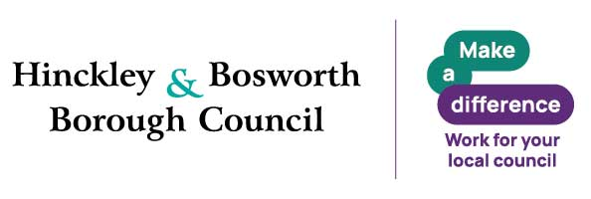
Why Join Hinckley & Bosworth Borough Council
A great place to work, grow and make a real difference. Join a flexible, supportive council offering great development, strong wellbeing, financial benefits and values that put people first.
Make a real difference in Hinckley & Bosworth.

Benefits*
- Flexible working – flexi‑time, hybrid, part‑time and compressed hours (role‑dependent)
- Generous annual leave – 26–33 days + bank holidays
- Career development – training, funded qualifications, apprenticeships, e‑learning
- Strong wellbeing support – EAP & counselling, occupational health, wellbeing sessions
- Financial benefits – competitive pay, cost‑of‑living increases, local government pension scheme
- Salary‑sacrifice schemes – tusker cars, tech, cycle to work
- Relocation package up to £5,000
- Lifestyle discounts – retail, travel, entertainment and more
Values and behaviours

We are energetic and passionate, proud of and dedicated to our area.

We strive for excellence. We learn, innovate, challenge, seek out opportunities and embrace new ideas.

We trust, respect and are honest. We listen to each other, to our communities and to our partners and work with them supportively to get things done.

We put the needs of our customers first. We care about being the best we can be and take responsibility for our actions.

Inclusive Employer
We are a Disability Confident and Care Leaver Friendly Employer. Guaranteed interviews are offered to eligible applicants who meet the essential criteria.

Reasonable adjustments are available throughout the recruitment process.

*Eligibility criteria applies

